Protection in law and practice: regional and global engagement on displacement in the context of climate change

**Moderated by Mr Niels Annen, Parliamentary State Secretary of German Federal Ministry for Economic Cooperation and Development**

**Opening by Filippo Grandi, High Commissioner, UNHCR**

***Speakers:***

**Ms. Ruvendrini Menikdiwela, Assistant High Commissioner (Protection), UNHCR**

**Ms. Rita Amukhobu, Head of Humanitarian Affairs at the Africa Union**

**Justice Natalia Ángel Cabo, Constitutional Court of Colombia**

**H.E. Ambassador James Waweru, Deputy Permanent Representative, Permanent Mission of the Republic of Kenya to the United Nations Office in Geneva**

**Prof. Walter Kälin, Envoy of the Chair, Platform on Disaster Displacement**

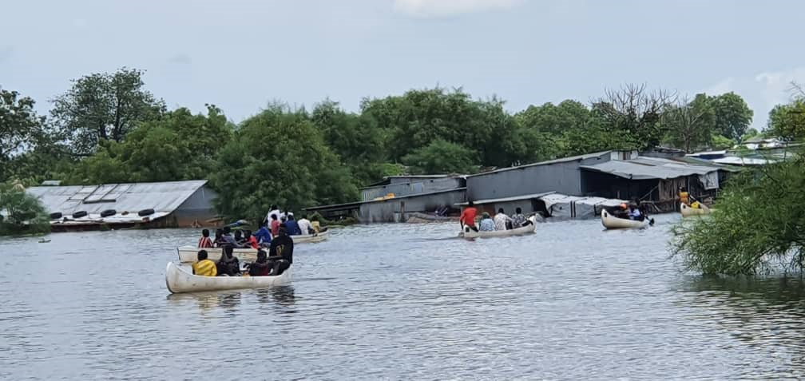

Pibor, South Sudan - Photo credit: © UNHCR

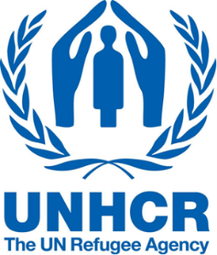There is increasing recognition of the urgent need for strengthened international cooperation to help equip countries, communities and individuals to address the adverse impacts of climate change, including in contexts where they interact with violence and persecution or multiply vulnerabilities in situations of displacement. Following the second Global Refugee Forum and the multi-stakeholder pledge on climate action, this side event will highlight the recent work of States, UNHCR and other partners to advance international protection in the context of climate change and disaster, including notably through regional efforts in the Americas and Africa. It will further underscore the importance of providing protection based on existing applicable instruments and supporting States particularly exposed to climate change impacts, including host countries, countries of origin and others.

**Tuesday 15 October 2024**

**13.30 to 14.45 am (Geneva time)**

Palais des Nations, Room XXVI

Sandwiches will be served outside of the room prior to the event.

Interpretation in English, French and Spanish will be available.